

Sod
Sod, also known as “Turf”, is grass. When harvested into rolls it’s held together by its roots and a thin layer of soil. Sod is usually used for lawns, golf courses, and sports stadiums around the world.

Light:
Most Sod should receive at least six hours of sunlight each day, though it can tolerate about 20% filter from trees.
Water:

Begin watering newly laid Sod within 30 minutes of installation. Apply at least 1 inch of water so that the soil beneath the turf is wet. Ideally 3 to 4 inches of soil beneath the surface should be moist. Continue watering new Sod twice per day, in the morning and afternoon—thorough, deep watering is best until the soil is saturated but not puddling. Within a few weeks, when the Sod has started rooting into the soil, you will not have to water it as much. After the Sod is well established (several weeks after installation) irrigating deeply and infrequently encourages roots to grow deep, making the turf more tolerant to drought.

Soil:
Loosen the top 6 to 8 inches of soil with a rototiller. Spread 2 inches of finished compost. Add 2 to 3 inches of sand to claylike soil to improve drainage. We recommend our Fox Farm soil.

Fertilizer:

Fertilize new Sod for the first time about six weeks after laying the Sod. Apply a slow-release, granular fertilizer with a 10-10-10 or similar formula rate.
For The Love of Plants:
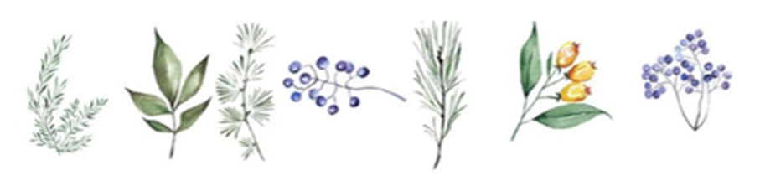
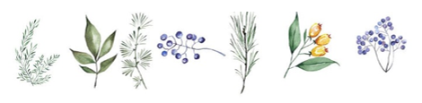
Sod is the most cost-effective solution to wind and water erosion.

