

Peperomia
Easy-to-grow, Peperomia add a touch of texture to the home, and some varieties trail. Peperomia vary in leaf and growth habit so much so that several grown together can appear to be a variety of different plants. With the same basic needs, however, care is easier than planting several different types of plants together.

Light:

They can grow in low light, but they prefer medium to high light.
Water:

Water when top inch of soil is dry.
Soil:
Standard, well-draining potting soil is best.

Fertilizer:
Fertilize once a week or so during active growth, lower strength and less often during slow growth.
For The Love of Plants:
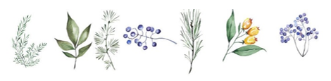

Peperomia are slow growers, so they don’t need much pruning or maintenance. They’ll live happily together for quite some time if planted as a combination and won’t overtake one another quickly.

