

Heuchera
Heuchera is a traditional perennial foliage plant, with new varieties introduced every year. Native to North America, the plants form round mounds with a woody rootstock or crown at their base and small bell-shaped flowers that begin in spring or early summer on the tall stems.

Light:
Most varieties of Heuchera do best in partial shade, especially in hotter climates. Their color can become washed out if they’re kept in full sun, and too much light can cause their leaves to scorch.
Water:

This plant has medium water needs and likes consistently moist soil. Established plants will tolerate some drought, but an inch of water per week is the best way to keep them happy. If you grow your Heuchera in full sun, plan to give them extra water—their shallow roots will need extra moisture during hot, sunny days.
Soil:

Heuchera prefers humus-rich soil with a neutral to slightly acidic soil pH, somewhere between 6.0 and 7.0. Good drainage is a must, especially in shaded areas, as sitting in the damp soil will cause he crown of the plant to rot. We recommend our Fox Farm Ocean Crest potting soil.
Fertilizer:

Feed Heuchera in the spring with a one-half-inch layer of compost or a light amount of slow-release fertilizer. This plant has light feeding needs; you should avoid heavy applications of quick-release fertilizers, as this will inhibit flowering.
For The Love of Plants:

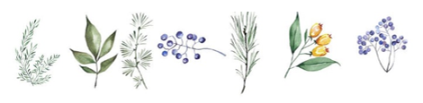
Rich in nectar, the flowers attract hummingbirds and butterflies, plus they make nice cut blooms. Their leaves are rounded, lobed, hairy, and evergreen or semi-evergreen, depending on the climate. Besides traditional green-leaved Heuchera, newer varieties have leaves in shades of purple, rose, lime green, gold, and more.

