

Hosta
Hostas are America's most popular perennial garden plant for very simple reasons: They are one of the few plants that thrive in shade, and they are extremely easy to care for and propagate. Hostas produce blooms on long stalks that extend well above the clumping foliage in late spring or summer, but the foliage is the main attraction.
Light:

Hostas can survive in full shade, but most varieties grow best when they receive dappled sun for a few hours each day. When plants have green and yellow variegated leaves, exposure to the morning sun helps enhance the yellow coloring. Check the specific light requirements of your Hosta variety. If the leaves develop brown tips, if they have faded areas, or if their color is dull, the plant may be getting too much sun.

Water:
Water Hostas as needed to keep the soil moist but not wet. Once established, Hostas will tolerate occasional dry soil, but they will not survive long periods of drought. Deeper, infrequent watering is better than frequent shallow applications.

Soil:
Hostas are tolerant of most types of soil, provided it is well-drained. They do not do well in clay soil, which holds too much moisture. They also like their soil rich and fertile, full of organic matter. We recommend our Fox Farm Ocean Crest potting soil.
Fertilizer:

The best and easiest way to feed Hostas is by adding a healthy layer of compost to the soil in the spring. This feeds nutrients into the soil and helps promote the soil food web. You can also feed Hostas with a well-balanced organic fertilizer, applied after planting or when plants begin to come up in spring.
For The Love of Plants:

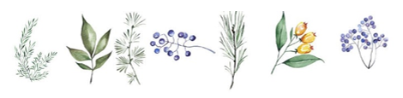
There are fast, medium, and slow growing varieties of Hostas. Smaller varieties tend to grow fastest and can reach their mature size in three to five years; larger types may take five to seven years. Hostas can be planted in early spring or as soon as the heat of summer ends in early fall.

