

Herbs
Herbs are a widely distributed and widespread group of plants with savory or aromatic properties that are used for flavoring and garnishing food, for medicinal purposes, or for fragrances.

Light:
They need sun, and lots of it! Most Herbs require at least 6 hours of sun per day outdoors. Indoors, much less light gets in, especially in the winter. So be sure you can place your herbs in a sunny spot, preferably in a south-facing window.
Water:

A good rule of thumb for most Herbs is to water about once per week. During extreme heat or drought conditions, sometimes twice per week will be needed. Water in the cooler hours of the morning, between 6-10 am, to avoid evaporation and allow for deep root soaking.
Soil:

Most Herbs grow best in soil with a pH level between 6.5 and 7.0, as close to neutral as possible. Some potting soils for Herbs can have a more alkaline or acidic profile. Acidic soils make nutrients more available, so if you want to supercharge the nutrition of your plants, it's good to pick an acidic one. We recommend our Fox Farm soil.
Fertilizer:

Though most Herbs don’t require much fertilizer, at some point they will need it. Herbs produce the most oils when they are given a steady feeding of a slow acting fertilizer such as fish emulsion, bone meal, cottonseed meal or blood meal. Add it to the soil at time of planting or potting.

For The Love of Plants:
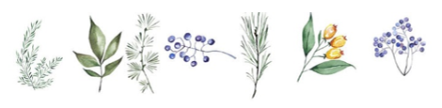
The difference between Herbs and Spices is in what part of the plant they come from. The green leafy parts of plants used for seasoning food are considered Herbs. Basil, mint, oregano, parsley, rosemary, thyme, and dill are all Herbs.

