

Lantana
Lantana plants have a unique vine-like sprawling appearance from woody branches. Lantana is also known for its rounded clusters of small, brightly colored flowers that may be yellow, orange, white, red, pink, blue, or purple.

Light:
Lantana needs to be in full sun for best flowering. You can plant in part shade, but it won’t flower as well.
Water:

Water newly planted Lantana regularly to ensure healthy root development. While established plants are drought tolerant, it’s best to water them about once a week.

Soil:
Lantana is tolerant of most soil types, but prefers rich, well-draining soil that is slightly acidic.

Fertilizer:
They don’t need much, just add a balanced fertilizer, like 10-10-10, at the beginning of spring.

For The Love of Plants:
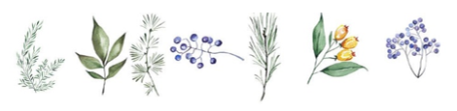
Lantana flowers attract bees and butterflies. Plus, some birds have been known to use the flowers to decorate their nests.

