

Succulents

These plants have special tissues that hold and store water, so they survive in environments that are too dry for other plants. They also survive for busy or forgetful gardeners who don’t always remember to water!
Light:
They prefer bright indoors or full sun outdoors.

Water:

Water and drain thoroughly, then let soil dry completely between waterings.
Soil:
Plant in cactus and succulent mix.

Fertilizer:
During active growth, fertilize every other week. Stop fertilizing in the winter or do so sparingly.
For The Love of Plants:
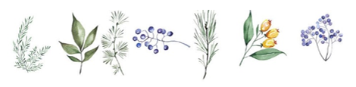

Succulents are much more cold-tolerant than many people assume. In the desert, where many of these plants originated. Temperatures can get down to 40˚F or colder. Leaving Succulents outside a little later than other houseplants can result in the foliage taking on deep, pretty coloration.

