

Sedum
Sedum is a flowering plant that is found on almost every continent. The plants come in a wide variety of heights, colors, and forms. Also known as Stonecrop, most Sedums are hardy, drought-tolerant succulents with thick, fleshy leaves that vary in shades. They typically have tiny, star-shaped flowers that bloom late in the growing season.

Light:
Most Sedum plants grow best in full sun, meaning at least six hours of direct sunlight on most days. Some varieties can tolerate partial shade, though they often won’t be as sturdy or bloom as profusely as they would in full sun.
Water:

Water new Sedum plants roughly once a week to prevent the soil from dying out. Once established, Sedum plants typically won’t need any supplemental watering unless you have a long stretch without rainfall and/or very hot temperatures. Thanks to their thick succulent leaves, sedum plants have good drought tolerance.
Soil:

In general, Sedum prefers a loose loamy, sandy, or gravelly soil with sharp drainage. When the soil retains too much water, as is often the case with a heavy wet clay soil, this can easily lead to root rot for Sedum. We recommend our Fox Farm Ocean Crest potting soil.
Fertilizer:

Sedum typically needs no supplemental fertilization and can tolerate nutrient-poor soil. In fact, if the soil is too rich, this can cause weak, leggy growth. If you have very poor soil, mixing some compost into it will generally be enough to give your Sedum a boost.

For The Love of Plants:
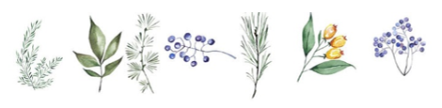
In general, the genus is divided into two categories: low-growing Sedum and upright Sedum. The low-growing Sedum stays short and spreads whereas the upright Sedum forms vertical clumps and looks great along borders.

