

Perennial Flowers

Perennial Flowers like hydrangeas live and flower for multiple years.
Light:
Most Perennials require either full sun or partial shade.
Water:

The general rule of thumb is one inch of water per week for established plantings. Less frequent but deep watering encourage Perennials to root more deeply and thus become better able to handle drought conditions. The most common and time efficient way to water Perennial gardens is to use soaker hoses.

Soil:
All Perennials need well-draining soil. To get more specific than that, you will need to know the particular flower. We recommend our Fox Farm soil.
Fertilizer:

Most Perennials would be happy with a good, all-purpose flower food or organic fertilizer; however, others may have specific preferences or needs. In general, using a natural, organic fertilizer is the preferred method because there is very little chance for burning your Perennial plants.
For The Love of Plants:

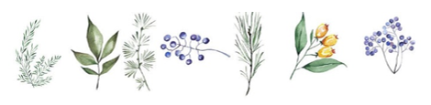
Perennials live for more than one year. They may bloom and set seed their first year, or they may take multiple years to flower. Perennials remain alive even after they flower. Some Perennials can live hundreds of years while others live less than ten years. While Perennials may appear to die during cold periods, they will regrow in the spring. It’s important to note that not all Perennials can survive cold temperatures. Tropical Perennial plants, sometimes known as tender Perennials, can survive years in warm areas but die during cold winters. Therefore, you’ll need to replant them each year in cold regions.

