

Begonias
Begonias are native to moist subtropical and tropical climates. These beautiful plants can be grown both indoors and outdoors.
Light:

All Begonias need bright, indirect light. This means the indoor varieties prefer a spot near a large window with a sheer curtain to protect them from any direct sunlight. Direct sun can burn their leaves.
Water:

Begonias thrive in soil that is neither dry nor saturated. A good rule of thumb is to water every two to four days. When it’s hot and dry you’ll need to water more often than when the air cools down and the soil holds more moisture.
Soil:

Begonias grow best in light, fertile, well-drained soil. Begonias are very susceptible to root and stem rot when exposed to cold, wet soils, so proper drainage is essential.
Fertilizer:
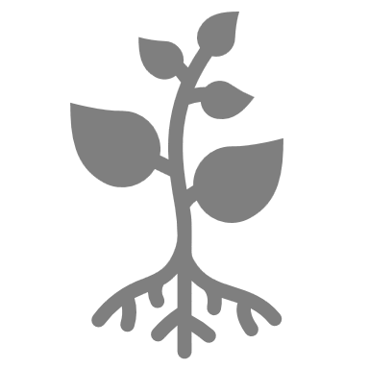
Begonias are heavy feeders and for best bloom production should be fed every two weeks. A high nitrogen plant food with a 10-10-5 formula early in the season is best.

For The Love of Plants:
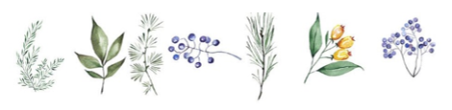
Begonias can grow from 8 inches to 2 feet in height, depending on the species. Begonias can also be grown as either an annual or a perennial plant.

