

Heather

Heather, commonly called Scottish Heather, is a beautiful, small, woody perennial. Its flowers, which bloom from mid-summer to early fall, are usually mauve, purple, or white. Its tiny, evergreen, scale-like leaves are valued just as much as its blooms. It is native to the bogs and moors of Scotland and other parts of Europe and is favored for the colorful flowers and foliage it adds to the landscape.
Light:

Heather blooms best in full sun, but it can benefit from some afternoon shade if necessary.
Water:
Water the plants faithfully when young. This plant requires one inch of water per week.

Soil:
Heather requires well-drained soil and does well in sandy soils or rocky terrain. It thrives in peaty, more acidic bogs. It does not need fertile soil. We recommend our Fox Farm Ocean Crest potting soil.
Fertilizer:

As long as Heather plants have some organic matter or peat moss in its soil, it does not need additional nutrients. Heather prefers acidic soil, so if you want to you can give an acidifying nitrogen fertilizer made especially for acid-loving plants once a year in early spring.
For The Love of Plants:

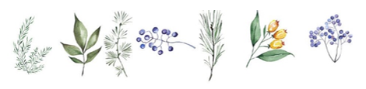
The best time to plant it is in spring or early fall. Heather is slow-growing and averages about 18-inches in height. A Heather's evergreen foliage changes and intensifies in hue during cooler temperatures. This plant is best-suited to be grown as ground cover, planted in rock gardens, or grown in rows to form borders.

