

Annual Flowers
Annual Flowers like sunflowers germinate, grow, flower, produce seeds, and die all in one year.

Light:
Most Annuals require full sun, but some can tolerate partial shade too.
Water:

Many Annuals need water every day, especially if they are in the sun. Don't wait for your Annuals to wilt before you water them. Instead, look for signs such as loss of gloss on leaves — or simply stick your finger into the soil. Most Annuals like soil slightly and evenly moist 2 or 3 inches down.

Soil:
All Annuals need well-draining soil. To get more specific than that, you will need to know the particular flower. We recommend our Fox Farm soil.
Fertilizer:

Annuals grow rapidly and need plenty of fuel. Work a slow-release fertilizer into the soil at planting time. Or use a liquid fertilizer on annuals in a garden bed every 7 to 14 days.
For The Love of Plants:

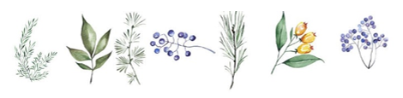
Just because a flower is annual doesn’t mean it can’t tolerate cold. While tender annuals can’t handle frost, hardy annuals can withstand some cold and light frost. If you are looking to plant winter flowers, make sure you find the right blooms.

