

Trees
A Tree is a perennial plant with an elongated stem, or trunk, usually supporting branches and leaves.
Light:

How much sun the plant gets depends on the particular Tree. Check the label of the plant to see if it requires full sun, partial shade, or shade. Full sun means it needs at least six hours of bright, direct light. Partial shade means the Tree needs 3-6 hours of sun or filtered sun throughout the day. Shade means the plant doesn’t need any sun at all.
Water:

Trees need moist, but not saturated, soil so they can grow well. From early spring through August, apply adequate water to all woody plants. From September through mid-October, gradually withhold water to allow plants to "harden off." This reduces the chances of wood damage by early freezing temperatures or snowstorms. In mid-November, prior to the ground freezing, apply water liberally to allow water to reach and saturate the root area. This will help to prevent winter kill. During the growing season, do not over-water. When you water, soak the soil approximately 12 inches deep. Wet the entire root area, which extends out to as much as three times the limb spread. Newly transplanted Trees need water more often than established ones. Adequate, but not excessive watering, results in healthy Trees.

Soil:
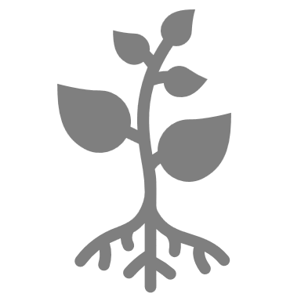
Most Trees are adaptable to a wide variety of soils as long as the soil is well drained. Clay soils and rocky soils are more likely to have drainage problems than sandy or loamy soils. We recommend our Fox Farm soil.
Fertilizer:

A complete fertilizer, such as 16-4-8, 12-6-6, or 12-4-8, is generally recommended.
For The Love of Plants:
Trees are the longest living organisms on Earth! They are also able to communicate and defend themselves against attacking insects!
